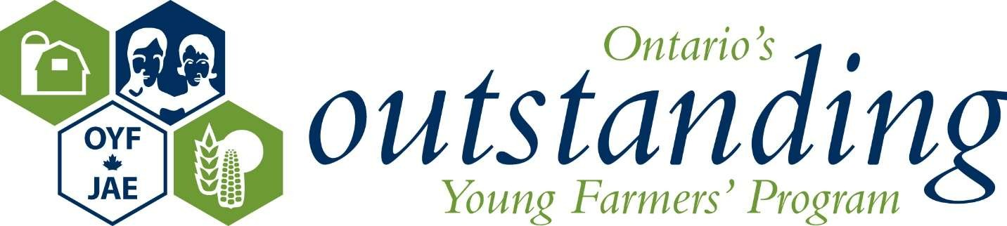

OYF Application Form FAQ’s

Q: I work with my family on the farm but as an employee, do I qualify?
A: No, we require that you have an investment stake (ownership) in your operation and are doing the majority of management decisions to qualify.

Q: I am 42 and my wife is 38, do we qualify?
A: Provided that your spouse is an equal partner in management decisions and earns over 2/3 of your gross personal revenue income from farming, you do qualify.

Q: I work part time off the farm or my spouse does, do we still qualify?
A: As long as over 2/3 of your gross personal income is generated from the farm, you qualify.

Q-Who sees my financial information?
A: We request your financial ratios be calculated and submitted with a verifying signature of your accountant or banker. We require 3 copies for the judges and they may be forwarded in 3 sealed envelopes. If you are the winner of your regional event, you will be required to submit more detailed financial information for the national competition. All information is held as confidential and is solely used by the judges in the selection process and all information is destroyed after.

Q: What is primary agriculture?
A: Products which are sourced from your own farm’s production.

Q: How much time do we need to commit?
A: The time it takes to complete the application form varies, as it is quite detailed. The regional competitions are approximately 2 days in length which includes 2 nights accommodations and meals. The national competition is a 5 day commitment, with all expenses paid. The networks and friendships you will create with others across Canada cannot be measured in value.

Q: What do we get?
A: The program is a peer recognition of your success. One winner will be selected at the Ontario level and two winners will be selected at the National level as the year’s model representatives of the agricultural industry. All winners become alumni of the association and are encouraged to return to grow the relationships they create with their OYF family. The national awards program alternates through the seven regions, providing participants with the opportunity to experience agriculture across Canada.

Q: What is OYF?
A: Our mission is to discover, celebrate and recognize progress and excellence in Canadian agriculture. We are a media and industry resource to model operations across all sectors of agriculture.

Q: Who judges?
A: A panel of three judges comprised of one OYF alumni and two respected industry representatives.

Q: What is “Other Information” on the form?
A: Information you wish to add to give us a better understanding of your operation.

Q: What if we don’t win Regionally?
A: All applicants are eligible to be re-nominated until they hit the age limit of 40. Those who compete automatically become alumni of the association and are encouraged to attend all future events to help welcome new alumni to the association.

