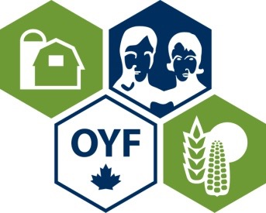
Who is Ontario’s Outstanding Young Farmer for 2019?

Here’s your chance to recognize someone with the title of the 2019 Ontario Outstanding Young Farmer. This award will be presented at the Regional Event to be held next September, in conjunction with Canada’s Outdoor Farm Show in Woodstock.

We are seeking people who contribute to the community, who seek new opportunities, and who generally are assets to Ontario’s agri-food industry.

Anyone can nominate a young farmer/farm couple/farm partnership for the award. The eligibility requirements are simply:
- Must be between the ages of 18 and 39
- Must have an ownership stake in their farm
- Must derive a minimum of 2/3 of their income from their farm

The process is simple.
- Nominations are submitted by April 30, 2019.
- Nominees are contacted and asked to complete an application form.
- A preliminary judging committee consisting of OOYF Alumni reviews the submitted application forms and contacts the top candidates. Their decision is based upon items such as the nominee’s progress in their agricultural career; adoption of soil, water, and energy conservation practices; financial and management practices and contribution to the well-being of the community, province, and nation.
- The top candidates then participate in an interview and presentation process at the regional event to be held in September, at Canada’s Outdoor Farm Show. The winner will be announced at the conclusion of the event.
- The provincial winner will then compete in the National competition which is designed to recognize young farmers that exemplify excellence in their profession.

If you know an outstanding young farmer, please nominate them by completing the nomination form (next page).

More information about OYF can be found on the website: www.ontario.oyfcanada.com
If you have questions about the nomination process, please contact:

Christina Pyke 613-561-5824 or pyke.christina@gmail.com
Jason Pyke 613-561-0389 or pykeview@gmail.com

Proudly sponsored by:
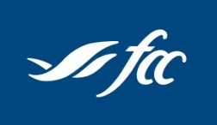
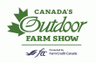

2019 Nomination Form (Please print)
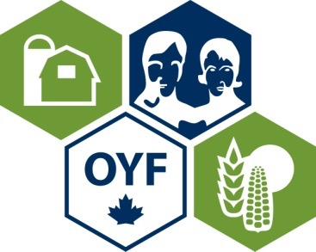

Name(s) of Nominee(s):
Address of Nominee:
County:
Age(s):
Phone (include area code):
Fax (include area code):
E-mail address:
Type of Operation:
Number of years involved in farming:
Percentage of income from farming:
Is the applicant aware of being nominated? | Yes No
Name and contact number of Nominator:
Organization (if applicable):
Signature

Nominations must be returned by April 30, 2019 to:

Christina Pyke 613-561-5824 or pyke.christina@gmail.com
Jason Pyke 613-561-0389 or pykeview@gmail.com
